PJI CANOPY CLUB ASSOCIATION

NEWSLETTER

Summer 2015

A MESSAGE FROM THE ASSOCIATION PRESIDENT
GROUP CAPTAIN (Ret’d) PETER WATSON FCMI

Welcome to our 2015 Summer/early Autumn Newsletter – the one that traditionally passes on details of our Annual Reunion and the Tatton Salver Golf Competition. Details appear later.

As some of you may know, Wg Cdr Wayne Loxton has taken early retirement, having accepted the offer of a post in industry for which a senior PJI Officer is ideally suited. No doubt he’ll tell you all about it when you next meet him, in his own inimitable style! It is therefore time for me to thank him personally, and on your behalf, for all the positive things he has done – not only as OC Airborne Delivery Wing (ADW), but also as Chairman of our Association. A particular thanks to Wayne, too, for volunteering to take over as our new Treasurer – proof (if any were needed) of his enthusiasm and continued wish to support the PJI Canopy Club Association. It is also time for me to thank George Long for his dedicated service as Treasurer over the past few years. You may rest assured that he has always put Association members’ interests absolutely to the fore – and has never been afraid to make his point-of-view known on your behalf! Well done, George – you can now breathe a huge sigh of relief!

Wg Cdr Jamie Simmonds has taken over the reins as OC ADW, and brings with him a wealth of experience in wider branch and trade matters, as you’ll read in his first ‘Notes from the Chair’ article which follows. Not only has he given an interesting insight into latest ADW activities and future plans; he’s also described the recent 75th Anniversary commemoration of the formation of No1 PTS (originally the Central Landing Establishment) and Airborne Forces, held at Tatton Park and Manchester International Airport (the former RAF Ringway). He’s illustrated his article with no fewer than 3 pictures – a ‘first’ for the Association Newsletter. I must say (on the basis that ‘a picture is worth a thousand words’) that I think this is an admirable idea.

Having mentioned the commemorative events at Manchester (and how good it was to see so many old friends and retired PJI Association members there, some of whom had travelled many hundreds of miles), it is perhaps timely to remind you that our own commemorative event will tie in nicely with our Annual Reunion. As you’ll see, it is to be held slightly later in the year than usual – principally so that we can hold the Dinner in the Officers’ Mess at Brize Norton, once again. Our Reunion Secretary, the redoubtable Doug Peacock has things well in hand, helped by the very able ADW WO and Chief Instructor, WO Ian Charnock and his ADW team. Ian is himself retiring from the Service in early December. Thank you in advance, Ian, for all that you have done on our behalf during your time in post. We wait with interest to hear who your successor will be. Whoever it is will have a hard act to follow.

So, overall, ADW and our Association both remain in good hands, and your Committee, which has recently seen several changes, continues to operate extremely well on your behalf. Perhaps a quick reminder of who does what would therefore be appropriate before I finish, to allow you to read on: Chairman – Wg Cdr Jamie Simmonds, Vice-Chairman – Glynn Allcock, Treasurer – Wayne Loxton, General Secretary - Mick Thelfall, Reunion Secretary – Doug Peacock, Assistant General Secretary – Chris Heathershaw, ADW Chief Instructor – WO Ian Charnock, ADW Rep – Sgt Ed Massey.

Best wishes

Peter Watson

----------------------

Notes from the Chair

Writing this piece, so soon in my tenure as OC ADW, truly feels as if I have been parachuted in from the relative comfort of HQ 22 Trg Gp ‘flying’ the SO1 Human Performance (SO1 Cmd PEd in old money) policy desk. The move into the ‘inner sanctum’ that is OC ADW’s office in the ADW HQ building is a most welcome change, I think I have got over the initial shock and know which way is up (reminds me of my early PX4 C130 exits!). As always we have been busy across the Wing’s departments and noticeably we are starting to spread into some new areas too.

My handover from Wayne felt as though it was finally complete when we met again at Tatton Park a few weeks after the official handover. The photo below shows it was an apt location for Wayne to state ‘you have the con!’ on his last day in uniform.

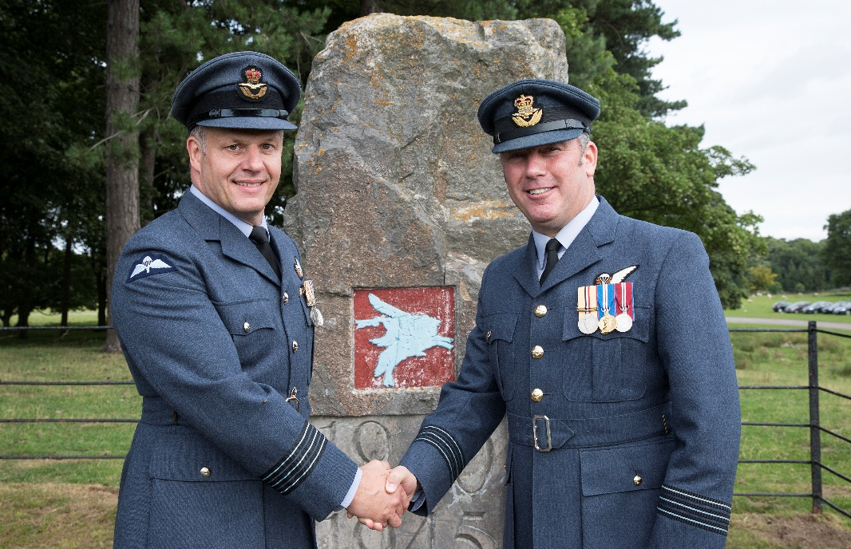

The training and exercise tempo within the Wing remains at a manageable, yet relentless pace. The return of 16 Air Assault Brigade from Op HERRICK (Afghanistan) sees continuous demand for Pitts Road/Brigade Parachute Sqn type activity. Recently this has involved the support to Exercise SWIFT RESPONSE, a NATO exercise billed as the largest NATO Airborne Exercise since the cold war. Our Continuation Training Flight provided support to 2 PARA as part of the UK support to this high profile exercise. In the coming months the flt will be operating out of Italy and Kenya in support to various exercises. Yes, the paras are well and truly back!

We recently commemorated the 75th Anniversary of the formation of No1 PTS and airborne forces at Tatton Park (formerly Tatton training DZ) and Manchester Airport (RAF Ringway and the first site of No 1 PTS). The day was a great occasion and we assisted the main organisers from 4 PARA to make the day a huge success with notable support to the day’s proceedings provided by Sqn Ldr Mike Burch (OC PTS) and Sgt Andy Banks (PTS Ops).

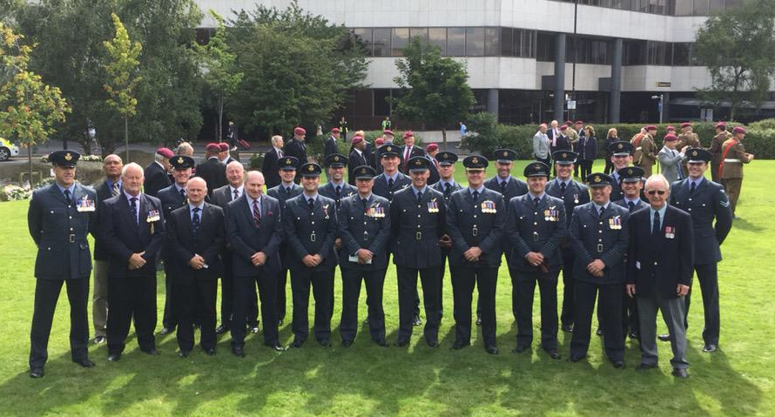
The RAF Brize Norton Station Commander, ADW serving staff and members of the Canopy Club Association at the RAF Ringwood memorial.

This summer we entered a team into the in the Inter Service Parachuting Championships between 10-14 Aug 15 at Netheravon. The ADW ‘PARATRASCH’ team competed in the AA & AAA categories of the 4-way formation skydiving competition. Some may recognise the team name used was the old Signal name for para matters. Despite limited outdoor training they placed 1st in the AA category. Due to poor weather on the final 2 days of the competition they only completed 4 of the 8 rounds in the AAA competition (we were joint 1st place after 4 rounds). The team comprised: Sgt Ady King, Sgt Danny Ball, Sgt Niel Flanagan Sgt Sam Bonsall and Sgt Dylan Bartle.

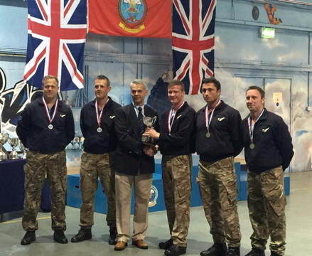
The ADW Paratrasch team receiving their reward at Netheravon

So to the future, we have exciting times to look forward to, the RAF Falcons are planning a display in South Korea and no doubt a few pit stops along the way and I am looking forward to visiting Blythe, California, the new location to conduct our High Altitude Parachute Course amongst other training. I intend to ‘pick up’ the staff, in true RAF Falcons Team Coach fashion, to shape the ADW team focus on our delivery across all areas to meet the challenges with a collegiate approach to enhance both the PJI cadre and that of our airborne colleagues.
---------------------

Secretary’s notes:

I continue to be amazed at the ability of our cadre both past and present which, due to the success of our Facebook page, I can now read about and peruse the photographic evidence of the many and varied para related activities by young and old on a daily basis. The proof of the fact that you are never too old to use social media, is how quickly Doug Peacock went from having never been on Facebook to becoming a regular contributor. If you are unsure of the Technology ask anybody over 14 (grandchildren would love to see what you have been part of!) Simply ask to join this closed group and you’re in!

Contact details

By far the quickest way of contacting people is via Email and it is frustrating when Emails ‘bounce’ back. Could I ask that you confirm your latest Email address on the forms enclosed.

Club subscriptions

I hope that you will allow me to yet again repeat a whinge I made in last year’s Newsletter and the year before! It is always hard work chasing a large number of subs (some late, some conspicuously AWOL). Club subs are charged in arrears for expenditure on members’ behalf over the course of that previous 12 months. With this in mind Wayne Loxton and I would appreciate payment by the requested date and thus in time to include the figures in the annual statement of accounts presented at the AGM. We are most grateful however to those members who always pay on time and to those who give so generously in the form of voluntary contributions; such gestures are much valued and appreciated.

TOOT BALDON – 5OTH ANNIVERSARY
On 6 July 2015, we commemorated the 50th Anniversary of the tragic Hastings crash that claimed the lives of 41 PJIs, aircrew and soldiers. It is always a sombre occasion, but we are extremely privileged that the local parish continue to honour our brethren in the way they do, and this year we supported them in equal measure with a fly past from a No 24 Sqn C130J and an excellent RAF Falcons display from a RN Sea King helicopter. The Team were extremely busy that day and had just completed a display at the F1 at Silverstone and the Sea King ensured that they made it on time – but only just, as the heavens opened shortly after exit and FS Ceri Marshman led the team onto the Village Green with Flt Lt Ollie Smith taking the salute in torrential rain. The Sea King landed on and took the lads back to Silverstone for tea and medals. It was a fitting memorial and a great day all round that was extremely well supported by the local villagers, serving PJIs and a large PJI Canopy Club contingent with our very own Standard flying proudly thanks to Smokey Furness. Whilst places are usually limited in St Lawrence’s church, the occasion is always marked on the first Sunday of July so put it in your diary for next year.

Thank you all for your support.

Grieve Carson's youngest son Jon has now completed over 140 marathons and has competed all over the world raising considerable sums for Charities. He pays for all his personal expenses and all monies raised are donated to Charity. His Charity this year is HELP FOR HEROES and if anyone would like to help Jon raise funds for this wonderful Charity you can make a donation by clicking on to https://www.justgiving.com/Jon-Carson10/ . Perhaps you would like to help Jon support Help For Heroes in 2015.

Obituaries

As we are all aware in the past year we lost 3 members of our cadre, Wilf Finbow, Gordon Sherman and John Gregor. Susan Sherman has asked me to pass on her thanks for the letters of support that had no return address. As ever I am indebted to the work of our Area Reps who have been in contact to offer support both to the Families of Members we have lost and with those with illness/injury. Could I ask that you all continue to keep your area rep informed of any change in the situation of any member.

Yet again I have to thank you all for your continued support and I look forward to seeing as many as you as possible at the reunion.

Best wishes

Mick Threlfall

-----------------

Reunion dinner

Dress code is lounge suit/jacket with tie and the charge for the 3 course dinner with wine is £35 per head. Timings are as usual, 7.30 for 8 pm. Please let me know if you would prefer a vegetarian option. Post dinner the Club President will present the Canopy Club Award of Merit to the serving PJI nominated by OC ADW. This year ADW will again be responding with a PJI Lifetime Achievement Award which will have been researched by the u/t PJI Course.

Members’ guests

In keeping with tradition and the amended constitution, we are very pleased to extend a warm invitation to members’ guests to join us for dinner and should they wish, the ADW based reunion activities the following day. Should you be planning to bring a guest or guests, please make sure to provide all the necessary detail on the Security Proforma at Club Form C.

Overnight accommodation

Many members will already have standing accommodation arrangements with fellow members or friends in the area. As on-base accommodation is NOT available this year members living locally may wish to offer a bed for the night. Please make your own arrangements. For those wishing to stay in a local hotel or B&B accommodation information can be found on the Witney town web site www.witney.net.
Last year Glan Evans, on your behalf, did some research, details below:

Premier Inn

For the 10 Oct, £72 per room double/twin
For the 11 Oct £82 per room double/twin

Full English breakfast £6.75 or Continental £6.25

Does have bar and restaurant

They said that it was probably better for individuals to check the internet for deals and offers.
They don't do group discounts as such but you could check with the area manager "Sally" on 01865 775872.

Four Pillars

Room only £90 double/twin
Bed +Breakfast £105
Dinner Bed +breakfast £135

You can pay upfront and get Bed +breakfast for £84, or dinner, bed + breakfast for £108.

However, if you cancel you lose your money on this deal
The area manager is Pete Clayton on 01993 893345 may be able to offer group discounts?
Glan concludes by stating that individual research on the internet to look for the best deal would be a good idea.

Access to RAF Brize Norton

Members planning to attend the the reunion on Friday 20 NOV and/or the AGM and presentations at ADW on Saturday 21 NOV are required to complete a Personal & Vehicle Security Application Form (Form C) for themselves (including their guest/s). When completed, please post this form to Doug Peacock, the PJI Canopy Club Reunion Rep no later than Monday 9th November. Passes will be available for collection on arrival at RAF Brize Norton. Please ensure that you (and your guest/s) are in possession of some form of photo ID. Should you encounter any hitch, ADW will be posting a PJI at the main Visitor Reception to assist your arrival and movement to ADW HQ.

AGM and programme of events

The outline of events at ADW is as follows:

1000 - 1045 - Arrival and coffee
1100 - 1200 - Club AGM
1200 - 1300 - ADW presentations and demos

Items for the AGM Agenda must be advised to the Gen Sec in writing by Friday 13 Nov .

---------------

And Finally………………

Jack Flint, now in his sixth year at the School of Combat Survival at RAF Mountbatten, was looking for a change of scenery and perhaps a little more adventure. I think this might have a little more than he asked for…………………………………………….

The job of Flight Sergeant Instructor at the Parachute and Jungle Survival School at Changi, Singapore, was being offered and so with a certain amount of sadness and a certain amount of excitement, I volunteered for the position and was immediately accepted.
I had already suffered the Jungle Survival Course during my learning phase at Mountbatten, so I slid easily into my new role at Changi. My worldwide survival experience was warmly received and being able to teach once again, basic parachuting to Ghurka, Malay and other nationalities made it a really worthwhile changeover, plus of course I was still going out on sea drills with the marine craft boys from Seletar. A great job!

Three months after our family move to Singapore, my wife Pam, gave birth to a beautiful baby girl who we named Kerry. The score now reads, one boy and two girls. Enough is enough thought I. No more children wanted. A Vasectomy it's got to be.

I was a member of the Jungle Rescue Team. I became the Explosive Expert who would blast 200ft high trees out into space if an aircraft crash site was found and room was needed to land a helicopter for possible rescue purposes. One member of the team was a doctor called Jack Gobi, a smashing guy and we became good friends. I mentioned to Jack one day, that I was thinking about having a Vasectomy and could he advise me where to go. "Sure," he said, "there's a retired Wing Commander Doctor living at a clinic on the Changi to Singapore Road and I'm told he's very good" "Thanks Jack," said I, "I'll go and see him."

I told Pam my wife, what my intentions were. She thought I was very brave —true! Eventually, plucking up courage, I set off on my motorbike looking for the clinic on the road to Singapore. I found the building I was looking for and leaving my motorbike outside, I went into the reception area where a Chinese girl was sitting at a desk. Overcoming my embarrassment, I told her what I wanted. She asked me to wait a while and went back into another room to fetch her boss. A portly Chinaman appeared. I was rather taken aback by this, but then I had met other foreign officers serving in the Royal Air Force, and he did speak perfect English.
"What made you come to me?" he asked. I told him he had been recommended by the Doctor at RAF Changi. This seemed to please the portly Chinaman very much and he agreed to carry out the snip. A date and a time were arranged.

The day arrived. I had shaved my delicate parts, and onto my motorbike and off to the clinic I went.

The Chinese girl receptionist told me to go to the back room, strip off and put on a rather grimy looking white dressing gown which she handed me, and to lay back on the bench. The back room was tiny. There were shelves on the walls mostly laden with jam type jars filled with liquid, foetuses and embryos of many babies. At this time I was having rather funny misgivings, but too late, the doctor and his receptionist came in. The receptionist was going to be the doctor's helper! "Bloody Hell," thought I.

The Doctor had a good look at his target, which was clean and shiny after the morning shave. He poked and prodded and then picked up a huge hypodermic needle. He told me he would give me a couple of Injections to deaden the area and with that he plunged the needle into my right testicle. I let out a loud WHOO-WHOO-WHOO, as a horrible type of pain gripped me. He then proceeded to do the same to the left testicle. Again, WHOO- WHOO-WHOO, escaped from my mouth! This was horrible! He left me for a while to let the injection take effect. On his return, he pinched my bits and asked whether I could feel it. I don't think I could feel the pinching, so he picked up a whopping great big scalpel that reminded me of a carving knife, and proceeded to cut into both sides of my treasure trove. I could feel no great pain, but I could feel the cutting sensation. He then groped inside to the right and cut whatever. "WHOO-WHOO-WHOO!" cried I. He asked if it was hurting me and I told him that it was a horrible type of hurt, one that I couldn't explain. "I'm surprised," said he. "I've inserted enough anesthetic to make an elephant go numb." Not that I'm bragging or anything!
Then on to the left side he went, groping and cutting. More WHOO-WHOO's.

After the cutting came the stitching up. "You can come off the bench now," he told me. "I'd like to see you again in about eight to ten days in order to take the stitches out." I thanked him and paid the fee.There was now no pain. The injection was finally taking effect. I gingerly climbed onto my motorbike and drove home. Once there, I relaxed and let Pam make a fuss of me.

Next morning, I had to be up early for work. The first lecture was Escape and Evasion. The rest of the Survival School staff know of my visit to the clinic but had asked me to please make the lecture if I could as I was the only instructor capable of doing it. I looked down at my bits and pieces as I was getting dressed. They looked really poorly. Swollen and black and blue all over.

I drove to work in my car and upon my arrival, got out of the car and hobbled over to the lecture room which had a thatched palm covered roof. The whole building was built up on stilts with steps leaving up into the room itself. The whole course of Aircrew Officers plus staff was waiting at the bottom of the steps. Upon seeing me hobbling over, they all let out a mighty cheer and stood there laughing their heads off at my sorry plight. I lifted each leg in turn as I mounted the steps. Each step brought a fresh cheer.

After a couple of days the swelling went down and my treasure trove had gone an orangey blue. Life seemed to be getting back to normal.
The next weekend I was supposed to be doing a Korean Karate Grading in Singapore. Should I or shouldn't I, thinks I. Well I decided to chance it. Once the grading started, there was I kicking and punching and really getting into it when suddenly, I had this funny feeling from down below. Directly the grading was over, I rushed to the toilets to inspect the damage. Crikey! The stitches had popped open. I certainly wasn't going back to the portly Chinaman, in fact I never did. I decided to let sleeping dogs lie and hope for the best. So long as little bits didn't drop out from my popped stitches, I'd probably get over it.

Some days later I attended a Jungle Rescue Team get-together. Jack Gobi the doctor was there. At a convenient time I sidled up to him and whispered, "could I have a word?" We went outside the building and I told him how brave I was by going to the Wing Commander Doctor and having the snip. However, I added, I was a little worried after my karate grading incident. "Drop your trousers," he said, "and let's have a look." No one was around, so I dropped my trousers. "Oh you've burst your stitches," said Jack Gobi, "but it looks alright, just take it easy."
"Thanks," said I, "but you might have told me the Wing Commander was a Chinaman.
"What on earth are you talking about?" asked Jack.
I explained to Jack what had happened. He almost fell to the ground in hysterical laughter.
"You narna. The Wing Commander Doctor is an Englishman not a Chinaman. You must have taken the wrong road to Singapore and finished up at a Chinese Butchers Clinic!" Someone should have taken a photograph of my face as he gave me this information. I'm sure it must have been a sight for sore eyes considering the shock I was now feeling! Oh my God, what if it's ruined my lovestyle, I mean lifestyle. Well time will tell Jack Gobi informed me. "Just relax and I'm sure it will be alright," said he.

To wind up this very true story, some weeks later, I was able to prove that everything was still 100% in working order.

The moral of this story is that the Road to Singapore is not always a Dream Road, as Bob Hope in his movie 'The Road to Singapore', would have us believe!

Just as a matter of interest, Jack Flint returned to the Combat Survival School at Mountbatten in 1973 after working with Special Forces on a parachute job. To this day, Jack still has a fear of Chinese Take-aways and portly looking Chinamen!

FORM A

To: Wayne Loxton, 10 De Havilland Road, Upper Rissington, Glos, GL542NZ (nlt 3 Nov 15)

From: (Please print Name & Address) ________________________________________________

_________________________________________________________________________________

____________________________________________________ Has this Changed? Yes/No

Telephone Number: ___________________________________ Has this Changed? Yes/No

E-Mail Address: ______________________________________ Has this Changed? Yes/No

Annual membership Fee to 31 Oct ‘15 £10.00 £ …………

reunion Dinner £35.00 per head £

CLUB MEMORABILIA
£ …………

…… Club Ties £9.00 Each £

…… Club Blazer Badges ~ Embroidered £12.00 Each £

…… Club Lapel badges ~ Enamelled Brevet £2.00 Each £

…… Club Lapel badges ~ Gilt Parachute £3.00 Each £ …

…….VOLUNTARY Donation to CLUB Funds £

Total £ …………

I enclose a cheque for £ ……………… Payable to PTS Canopy Club

Date: Signature:

FORM B

To: Mick Threlfall, 17 Bryony Gardens, Shilton Park, Carterton, Oxon, OX18 1JN

From: (Please print Details)________________________________________________

ADDRESS_________________________________________________________________

____________________________________________________ Has this Changed? Yes/No

Telephone Number: ___________________________________ Has this Changed? Yes/No

E-Mail Address: ______________________________________ Has this Changed? Yes/No

Annual membership Fee to 31 Oct 15 £10.00 £ …………

reunion dinner/s @ £35 PER HEAD* £…………..

voluntary Donation to Club Funds £ …………

Total £ …………

THE FOLLOWING INFORMATION WILL ALSO WILL HELP THE ADMIN TASK:

I plan to attend the club agm at adw raf brize norton on sat 21 November YES/NO
(if yes please compete and submit the personal & vehicle security application (Form C)

*please provide overleaf the names of any guest/s that you have invited to the reunion dinner

i have sent my form a and cheque to Wayne loxton, Form C to Doug Peacock.

Date: Signature:

Form C (4th revision 1 September 2015)

To: Doug Peacock, 11 Godwyn Close, Abingdon, OX14 1BU

PJI CANOPY CLUB ASSOCIATION REUNION – RAF BRIZE NORTON 20 NOVEMBER 2015 (19.30 for 20.00)

CONFIRMATION OF ATTENDANCE & APPLICATION FOR PERSONAL & CAR SECURITY PASSES

1. I confirm I shall/shall not be attending the Reunion Dinner on 20 November 2015 (delete as applicable).

2. Please note that, regrettably, there will be no PTSU accommodation available this year.

3. Return transport is available between nominated hotels in Witney and Burford subject to demand.

4. I do/do not require transport on 20 November from

Witney Premier Inn

Witney 4 Pillars Hotel

Other ………………………………….

Last name: ______________________ First name: ____________________________

Address:______________________________________________________________

Telephone Number: ______________________Mobile Number:_________________

Car Make and Model: ________________________________Colour: _____________

Registration Number: ______________________________

I have invited the following guest(s) for the Reunion Dinner and have paid the appropriate Dinner fee(s) to the Hon. Treasurer

Last name: ______________________ First name: ____________________________

Last name: ______________________ First name: ____________________________

Last name: ______________________ First name: ____________________________

The following are car pax. or drivers only, requiring personal and car security passes.

Last name: ______________________ First name: ____________________________

Last name: ______________________ First name: ____________________________

Please append additional (a or b) guests' details on the reverse of this form.

Please now return:

Form A to the Hon. Treasurer, (Wayne Loxton) No later than 2 November

Form B to the General Secretary (Mick Threlfall) No later than 2 November

Form C to the Reunion Secretary (Doug Peacock) No later than 2 November

and the tear off slip for the Tatton Salver to Paul Floyd no later than Friday 13 November

THE 2015 TATTON SALVER GOLF COMPETITON – FRIDAY 20 NOVEMBER

The 2015 Tatton Salver Golf Competition will take place on Friday 20 November at Witney Lakes Golf Resort. Timings are as follows:

Arrive at Witney Lakes between 0830 - 0930hrs - Coffee/Tea and Bacon Roll available in the Sports Bar.
First tee off time at 0930hrs (18 holes stapleford off full Hcp). Depending on numbers I may look to start on the 1st and 10th to combat the lack of daylight hours.

Competitors will be playing for the following:

Tatton Salver Trophy – 18 Hcp and below.
Hackers and Diggers – 19 Hcp and above.
Nearest the pin.
Longest drive.

The cost of the day will be £22.00 per head payable on the day in CASH only.

If you wish to take part please fill out the entry form below and send to:

Warrant Officer Paul Floyd
Team Manager
RAF Falcons Parachute Display Team
Airborne Delivery Wing
Carterton
Oxfordshire
OX18 3LX

Alternatively, email the required information to: paul.floyd586@mod.uk

To arrive no later than Friday 13 November 2015
--------------------------------------------------------------------------------------------------------------

THE 2015 TATTON SALVER GOLF COMPETITION – ENTRY FORM

I wish to enter the 2015 Tatton Salver Golf Competition to be played at Witney Lakes Golf Resort on Friday 20 November.

First Name: Surname:

Address:

Telephone No: Email Address:_____________________________

OFFICIAL HANDICAP (or a realistic estimate):

